**Hyper Local Search Engine**

**Request for Proposal**

Web & Mobile Apps Development

**Summary:**

Etisalat Information Services (eIS) is accepting proposals to design and develop hyper local search engine (Web & Mobile apps) similar to connect.ae. This project will be design concept to completion production. The purpose of this RFP is to provide fair evaluation of different commercial proposals. The existing connect.ae website was originally designed and produced during early 2015 since then minor enhancements done on a timely basis on both Website & Mobile Apps.

**Proposal Guidelines and Requirements:**

This is an open and competitive process.

Proposals received after 4:00pm, Monday, June 5th 2017 will not be considered and will be returned unopened. The proposal must contain the signature of a duly authorized officer or agent of the company submitting the proposal.

The price you quote should be inclusive. If your price excludes certain fees or charges, you must provide a detailed list of excluded fees with a complete explanation of the nature of those fees.

If the execution of work to be performed by your company requires the hiring of sub-contractors you must clearly state this in your proposal. Sub-contractors must be identified and the work they will perform must be defined. In your proposal please provide the name, address of the sub-contractor. Etisalat Information Services will not refuse a proposal based upon the use of sub-contractors; however we retain the right to refuse the sub-contractors you have selected.

**Contract Terms:**

Etisalat Information Services (eIS) will negotiate contract terms upon selection. All contracts are subject to review by Etisalat Information Services Project team, and a project will be awarded upon signing of an agreement or contract, which outlines terms, scope, budget and other necessary items.

**Purpose, Description and Objectives:**

**Purpose**

**Since directory media advertising industry has been evolving rapidly in digital space & realizing the declining trend in print directories,** eIS is planning to come up with hyper local search engine (similar to Connect.ae & 2gis.ae already live in the UAE market).

eIS management is currently planning to develop the entire platform with the same functionalities or more and to employ product development team to enhance further with an agile approach moving forward. Upon completion of the development of the website & mobile apps, eIS technical team will assume full responsibility for web site content maintenance and administration. All content, coding and graphics will become the sole property of Etisalat Information Services (eIS).

**Description**

Create a flexible, informative web site & mobile apps that is easy to maintain. We must develop a user friendly site with an intuitive interface that can deliver large amounts of constantly changing information to our key audiences. eIS team prefers to develop a custom made CMS which needs to be integrated with our internal CRM (used for company updates & provisioning now). Adding & Updating static pages can be done using the same custom-made CMS and we are open to any open source database for this development.

Etisalat Information Services will maintain ultimate editorial control of content. Administration of web content will be based on roles to control access and work flow (e.g. author, reviewer/editor, and publisher) same practice as eIS backend team follows as of now.

To be effective, our web site & mobiles apps must be:

* Easy and intuitive
* Visually pleasing
* Informative
* Safe and secure
* Quick to load and operate
* Responsive (Mobile & Tab)

**Specific Strategies**

* Maximize web-based technologies
* Build member loyalty and enhance customer relationships
* Improve program delivery and service
* Provide focused web-based solutions
* Increase market share
* Strengthen customer relationships and Retain current customers
* Present comprehensive information and resources in an easy to use format

In short we must tell our story through the use of compelling visuals, intuitive navigation, and concise messaging.

**Requirements in Detail:**

**Home Page New Design Requirement:**

* Refer to connect.ae layout; Home page should be similar to that one.
* Separate sections for Promotions with in home page
* Separate sections for Time bound category Promotions, refer to connect.ae home page
* Hamburger Navigation
  + Links under Hamburger Navigation should be managed by CMS
* Space for Mobile app downloads
* Provision for newsletter signup & store it in DB
* On the load of home page, the image background should be shown backside of search bar. This image has to be loaded one after another. This function to be controlled by CMS.
* Elements to be shown;
  + Featured Deals/Promotions – should be able to categorize and prioritize as per more commercials paid.
  + Add to Address Book
* Advertise with us – similar to yellowpages.com

Header:

* To make it simple – just with product logo, language switch, Sign and login links only.
* Header links to be managed by CMS

Footer:

* Sitemap links
* Newsletter signup textbox and submit button.
* Footer links to be managed by CMS

**Category & Other Promotions (in home page) explained:**

Promotions:

* Time bound categories to be listed in the home page. For ex: time between 6AM to 11am, we should list the categories like Coffee shop, Restaurants for breakfast etc and from 12pm to 3pm, Lunch restaurants, Juice bar etc. This category allocation and landing page link should be configured from the backend.
* Adding SME company profile snapshot promotion resulting in the single static page (with the standard template), the information furnished in it needs to be controlled by CMS. Front end will look like similar to yellowpages.com popular article section. This space would be commercialized later.

**Search Logic Detailed:**

Home page will have one field search bar ideally located in the mid of the page, upper half of the page similar to the interface like Google search. Typical long length text field, where user can add keywords/business names/product names etc. Location enable/disable button should be placed right next to the text box and search button to be placed similar to the one shown in Connect.ae

Suggest Function to work as follows;

* Maximum amount of suggestions displayed is 5
* Changes with each written token, included when typing in space
* Suggestions are based on our own content: Keywords, company names, categories (with connected keywords), and geographical places.
* The source of the suggested phrase is indicated by the symbols to the left of the suggestion
  + *magnifying glass: no specific source - you perform a search for everything in our base*
  + *briefcase: a specific company*
  + *POI: a specific place*
  + *Clock: previous searches.*
* When clicking a company, you end up on the company’s profile page.
* Clicking on a suggested POI takes you to the map section of the service
* Suggest exists on landing pages (result pages), company pages
* The logic is the same across all platforms (web & mobile apps)

**Hyper local search explained:**

Hyperlocal, as it’s called in ad tech circles, allows marketers to use a smartphone’s GPS data to geographically target audiences for the purpose of delivering relevant ads. The same is applicable for Web/Desktop users with location enable button shown next to the search box. When a person uses an app on their smartphone, the app may ask for permission to access the location data of the phone.

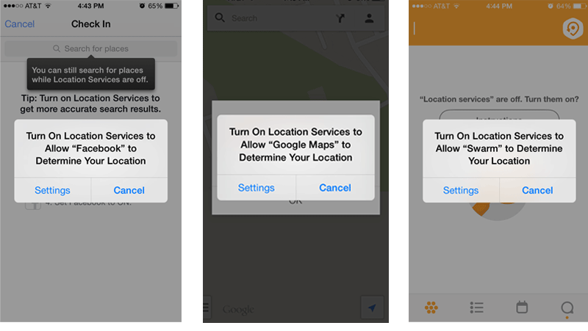

If an app user accepts this location-sharing request, the app will basically be aware of their GPS coordinates at all times. If the app also happens to be supported by ads, it’s highly likely that these coordinates will be passed along to the ad network or ad exchange that sells the ad space to advertisers.

At its most basic level, hyperlocal simply involves creating a zone or “[geo-fence](http://en.wikipedia.org/wiki/Geo-fence)” around a GPS coordinate, and targeting all users that pass through it. This zone can be as small as a few feet in radius. Most buying platforms have either a mapping integration built-in, or allow you to upload a list of GPS coordinates that you want to target.

**What are we selling?**

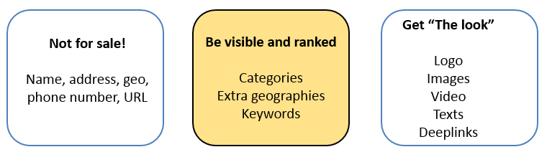

**What is searchable?**

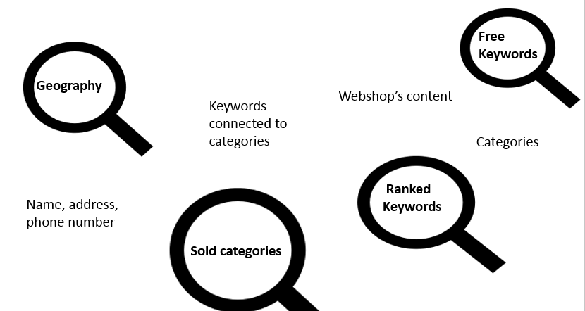

**Geographical Searchability:**

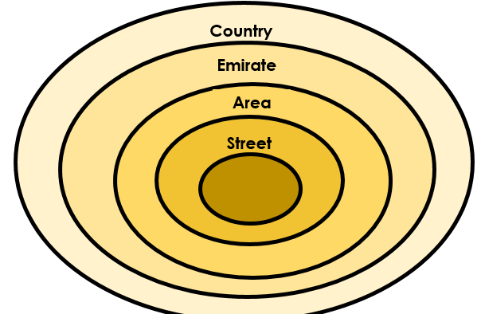

The customer is searchable in the area he is located, and all areas above in the hierarchy. It is also possible to buy extra geographies/Emirates if the client has bigger network of branches.

**Relevance Ranking company search:**

The relevance ranking is way of presenting the most relevant companies to the users. It is based on the data sources we have, and combining them in a sensible manner.

The relevance levels are ordered by “how sure are we which company you are searching for”. A phone number is less ambiguous than a part of a company name.

**Search Logic in all platforms:**

* Several of the relevance levels are stemmed.
* Several are normalized (e = é)
* Fuzzy logic - Restaurant vs Restuarent
* Synonyms for all parts of the service are handled manually in system
* On all searches containing more than two search words, we try to identify if the search is done with a geography.
  + We identify geographical searches by starting at the very end of the search phrase, trying to see if the last word is a geographical one.
  + We keep checking if the words are geographical until we meet a non-geographical word, working from the last word to the first search word.
  + Example: “restaurant karama dubai”. restaurant is a keyword. Karama is a part of city Dubai. Search phrase is identified as “restaurant” in “karama dubai”

**Ranking in Desktop:**

The commercial ranking is based on which commercial “package” the customer has bought. Commercial ranking is secondary in the ranking model - the relevance is most important

**Category keywords**

**Category name**

**Exact company name**

**Ranked keywords/prod.files/free KW**

**Part of company name**

**Non-customers: keywords, category keywords etc.**

**1**

**2**

**4**

**5**

**6**

**7**

**Partially hit on category name**

**3**

Ranking order

* Default sorting is by relevance, as explained previously
* We use geo identification on all searches (if the user allows us to)
* This allows us to sort all searches by closest to the user, regardless of the relevance
* In addition to this, the user can sort by reviews.

**Ranking in Mobile Apps/Responsive Web:**

The search behavior is a bit different in mobile.

* Possibility to pinpoint an exact location
* Start screen is a map, the feeling of “local” is high
* The user situation is more “on the go” than when searching on desktop
* Searches including a geographical area is quite different from searching without a specific geo area.

Ranking order

**1**

**2**

**4**

**5**

**6**

**7**

**8**

**3**

**Category keywords**

**Category name**

**Exact company name**

**Partially hit on category name**

**Part of company name**

**Non-customers: keywords, category keywords etc.**

**Mobile keywords**

**Ranked keywords/prod.files/free KW**

With geo: “Restaurant Dubai”

* Identification of geo happens as it does online.
* As on desktop, we display all companies with the correct, whether it is located within the geo, or the geo is bought.
* The map is always in the background of the result list, and all companies with addresses connected to their listing is displayed with POIs

Without geo: “Restaurant”

* The search performed is always a close to me
* Only companies with an address are displayed in the result list.
* The search is performed within a bounding box.
* Not all relevance levels “qualify” as good hits on close to me searches.
* If no companies with good quality exists, the area we search in is expanded
* Perfect hits on name searches are inserted into the result list, even if they are far away.

**Relevance Logic – Example below;**

**Listings on our result list**

**1 - Customer**

Customer name: Rolls N Rice Restaurant

Location/municipality: Abu Dhabi

Extra Geography: Dubai

Category name: Restaurants

Online Package: Package 2

Mobile package: Standard

Ranked keywords: Sushi, take away, chicken, Japanese

Free keywords: fish, Continental, romantic, cheap

Category keywords: food, dinner, eat out

**2 - Customer**

Customer name: Tandoori Corner Restaurant

Location/municipality: Dubai

Extra municipality: -

Category name: Restaurants

Online Package: Package 3

Mobile package: Silver

Ranked keywords: fish, chicken, set menu, dinner

Free keywords: romantic, take away

Category keywords: food, dinner, eat out

**3 - Free listing**

Customer name: Burger King

Location/municipality: Abu Dhabi

Extra municipality: N/A

Category name (free listing category) : Restaurants

Online Package: N/A

Mobile package: N/A

Ranked keywords: N/A

Free keywords: fish, steak, dinner, take away

Category keywords: food, dinner, eat out,

**Searches - desktop**

Search: **restaurant**

Result list

1 Rolls N Rice Restaurant (relevance: HEADING_EXACT)

2 Tandoori Corner Restaurant (relevance: HEADING_EXACT)

3 Burger King (relevance: HEADING_NON_CUSTOMER)

Explanation: All have the category “restaurant”, listings are sorted by ranking on commercial ranking (package). Highest package “wins”

Search: **sushi**

Result list

1 Rolls N Rice Restaurant (RANKED_PHRASE)

Explanation: Only company with this as a keyword. Ranked keyword ranks higher than a hit on partly hit on company name, COMPANY_PART

Search: **Burger**

Result list

3 Burger King (COMPANY_PART)

Explanation: None of the customers has burger as a keyword, only the free listing is searchable for this as a part of company name.

Search: **Steak**

Result list

3 Burger King (FREE_KEYWORD_NON_CUSTOMER)

Explanation: None of the customers has steak as a keyword, only the free listing is searchable for this as a keyword.

Search: **romantic dinner**

Result list

2 Tandoori Corner Restaurant (relevance: RANKED_PHRASE)

1 Rolls N Rice Restaurant (relevance: FREE_KEYWORD)

Explanation: Tandoori Corner has *dinner* as a ranked keyword, and *romantic* as a free keyword. The listings are always ranked on the highest relevance level possible, so Tandoori Corner gets the first place in the result list. Rolls N Rice has *romantic* as a free keyword, and *dinner* as a category keyword. Free keyword is the highest relevance level the company gets for this search. Even if Rolls N Rice has a higher package, the it will rank further down on the result page.

Search: **Fish Dubai**

Result list

2 Tandoori Corner Restaurant (RANKED_PHRASE)

1 Rolls N Rice Restaurant (FREE_KEYWORD)

Explanation: Tandoori Corner has *fish* as a ranked keyword, Rolls N Rice only has the word as a free keyword. Rolls N Rice is not located in Dubai, but is on the result list because of the extra bought geography.

**Searches in app - with geo**

Search: **Chicken Dubai**

Result list

2 Tandoori Corner Restaurant (RANKED_PHRASE)

1 Rolls N Rice Restaurant (RANKED_PHRASE)

Explanation: Both company has *chicken* as a ranked keyword. Both companies are searchable in geography Dubai. Tandoori Corner ranks above Rolls N Rice because it has a larger Mobile package.

Search: **take away Abu Dhabi**

Result list

1 Rolls N Rice Restaurant (RANKED_PHRASE)

3 Burger King (FREE_KEYWORD_NON_CUSTOMER)

Explanation: take away is a ranked keyword for Rolls N Rice Restaurant, and only a free keyword for Burger King, which isn’t even a customer.

**Searches in app - without geo.**

**Location: Al Mushrif, indicated with a blue dot**

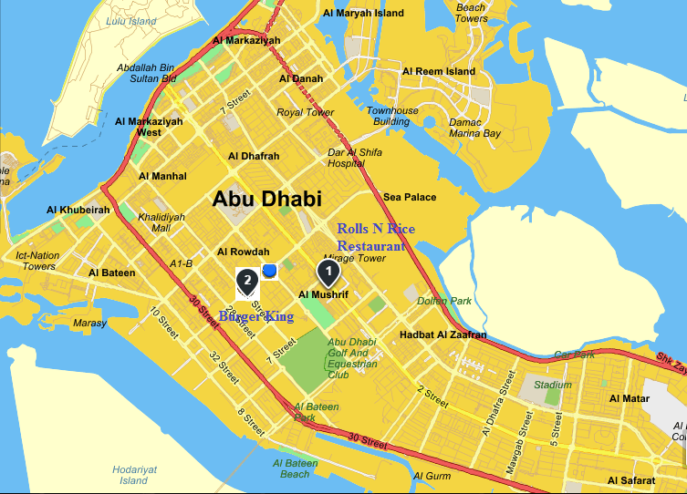

Search: **take away**

Result list

1 Rolls N Rice Restaurant (RANKED_PHRASE)

2 Burger King (FREE_KEYWORD_NON_CUSTOMER)  
Explanation: Both listings are within 3 km of where I am located, so even if Burger King is closer to my location, Rolls N Rice outranks the free listing. The listing for Tandoori Corner is in another city, and is not displayed.

**Search Results Page:**

Search results interface should be similar or better than currently shown in Connect.ae. If the listing is FREE, it would show only the basic company details. If it is paid listing, it’ll have added information in the interface similar to the one’s showed in connect.ae

Detailed individual paid products are below;

Company description (with limitation of words), Website, Logo, Opening hours, Deep link, Image gallery, Cover page, Video, social media links & download coupon link

User will have access to post the reviews. There should be review-handling module in the backend, the moderator checks the reviews and publish it live. Two additional functionality requirements are forwarding the company details via SMS gateway & send an email function.

**New additions:**

* Map background interface for Desktop version can be explored with new technologies.
* Filter functionality to be same as currently shown in Connect.ae
* Sponsor Ad section to be added (Text based Ads)
* Suggested keywords and categories information should be there in the results.
* To keep fixed home page header on scrolling down.
* Search Smart Suggestions
* Sort by area, by relavance,by A – Z

By default, the search results has to load the relevance part of the search keyword/phrase. The result page will have standard pagination navigation below with every page should load at least 20 listings. All the 20 listings map coordinates/pointers should be shown in the Map snapshot area shown in the right margin of the page (similar to Connect.ae). If a scenario of having paid customers of more than 20 customer for a particular category search results, we need to have random loading of business listing in the desktop, in the mobile apps/responsive, it should be typical hyper local search logic as explained above.

The search results page will have display ads place holders (different sizes similar to Connect.ae now) and all the display ads should be run & managed by the Ad management server.

**Profile Page:**

Profile page of the free listing will carry the same information shown in the search result. Profile page of the paid listing will have all paid products info (collected it through the backend). The interface design and other components of the profile page should be exactly similar to the Connect.ae profile page.

Sharing the profile page function should be available as SMS forward, Email forward & Save as Vcard and also all social media platforms for a sharing to be performed.

**Company XML by Examples**

Products

* Logo
* Homepage
* Email
* Click to Call
* Company Description

Permission Products

* Ranked Search Word Limit
* Deeplink
* PDF
* Search Word Ad Limit

**Product: Logo**

Displays the logo for a company. If the company has bought the logo product this is shown in the hit on the result page as well as on the profile page. The logo is also a link to the company's homepage, if available. Otherwise it is not clickable.

**Example**

 <product name="logo" scope_company_page="1" scope_result_set="1">  
       <product_attribute>  
         <file>  
           <id>1153837</id>  
           <extension>gif</extension>  
           <dir_path>837</dir_path>  
         </file>  
       </product_attribute>  
     </product>

**Fields**

*id* - The filename on the filesystem of the logo, without extension.

*extension* - The filename extension.

*dir_path* - The subdirectory where to find the logo on the filesystem.

*name* - The name of the logo. Has to be “logo”.

*scope_company_page* -  Set 1 to display the logo on the detailed company page. Set to 0 to exclude the logo on the detailed company page.

*scope_reuslt_set* -  Set to 1 to display the logo on the hit list. Set to 0 to exclude the logo on the hitlist.

**Product: Homepage**

Displays the homepage link for a company.

**Example**

<product name="homepage" scope_company_page="1" scope_result_set="1">  
       <product_attribute label="www.gulfnews.com">  
         <url>  
           <proto>http</proto>  
           <link>www. gulfnews.com</link>  
         </url>  
       </product_attribute>  
     </product>

**Fields**

*name -* The name of the product. Has to be “homepage”.

*scope_company_page* -  Set 1 to display the url on the detailed company page. Set to 0 to exclude the url on the detailed company page.

*scope_reuslt_set* -  Set to 1 to display the url on the hit list. Set to 0 to exclude the url on the hitlist.

*label* - The link label to be displayed for the user.

*proto -* The homepage protocol. Has to be http.

*link* - The destination of the homepage link.

**Product: Email**

Displays the email address for a company.

**Example**

<product name="email" scope_company_page="1" scope_result_set="1">  
       <product_attribute label="info@gulfnews.com">  
         <email>  
           <link>info@gulfnews.com</link>  
         </email>  
       </product_attribute>  
     </product>

**Fields**

*name -* The name of the product. Has to be “email”.

*scope_company_page* -  Set 1 to display the email link on the detailed company page. Set to 0 to exclude the email link on the detailed company page.

*scope_reuslt_set* -  Set to 1 to display the email link on the hit list. Set to 0 to exclude the email link  on the hitlist.

*label* - The link label to be displayed for the user.

*link* - The email address.

**Product: Click to Call**

Adds call us for free feature for a company.

**Example**

<product name="click_to_call" scope_company_page="1" scope_result_set="1">  
       <product_attribute label="Ring oss gratis">  
         <phone>  
           <area_nr>046</area_nr>  
           <phone_nr>13 13 33</phone_nr>  
         </phone>  
       </product_attribute>  
     </product>

**Fields**

*name -* The name of the product. Has to be “click_to_call”.

*scope_company_page* -  Set 1 to display the click to call link on the detailed company page. Set to 0 to exclude the click to call  link on the detailed company page.

*scope_reuslt_set* -  Set to 1 to display the click to call link on the hit list. Set to 0 to exclude the click to call link on the hitlist.

*label* - The link label to be displayed for the user.

*area_nr*  - The area number of the phone number.

*phone_nr* - The destination phone number for the company.

**Product: Company Description**

Displays the company description of a company.

**Example**

<product name="company_description" scope_company_page="1" scope_result_set="1">  
       <product_attribute length="280">  
         <mixed_text>  
           <text>Catering- blabla abla ablablablabla blabla abla ablablablabla blabla abla ablablablabla blabla abla ablablablabla blabla abla ablablablabla.</text>  
         </mixed_text>  
       </product_attribute>  
     </product>

**Fields**

*name -* The name of the product. Has to be “company_description”.

*scope_company_page* -  Set 1 to display the full company description on the detailed company page. Set to 0 to exclude the full company description on the detailed company page.

*scope_reuslt_set* -  Set to 1 to display the first 150 chars of the company description on the hit list. Set to 0 to exclude the company description on the hitlist.

*length* - The number of characters for the full company description.

*text -* The company description displayed for the user.

**Permission Product: Ranked Search Word Limit**

Set the number of ranked search words allowed. The search words are managed in the PSM system.

**Example**

<product name="ranked_searchword_limit" scope_company_page="0" scope_result_set="1">

<product_attribute>

<limit>40</limit>

</product_attribute>

</product>

**Fields**

*name -* The name of the product. Has to be “ranked_searchword_limit”.

*scope_company_page -* Has to be 0.

*scope_result_set -* Has to be 1.

*limit -* The number of ranked search words allowed. The search words are managed in the backend application/Admin panel.

**Permission Product: Deeplink**

Set the number of custom url links allowed. The urls are managed in the backend application/Admin panel.

**Example**

<product name="deeplink" scope_company_page="0" scope_result_set="1">

<product_attribute>

<limit>10</limit>

</product_attribute>

</product>

**Fields**

*name -* The name of the product. Has to be “deeplink”.

*scope_company_page -* Has to be 0.

*scope_result_set -* Has to be 1.

*limit -* The number of custom url links allowed. The urls are managed in the PSM system.

**Permission Product: PDF**

Number of PDF files allowed to be registered in the PSM system.

**Example**

<product name="pdf">

<product_attribute>

<limit>1</limit>

</product_attribute>

</product>

**Fields**

*name -* The name of the product. Has to be “pdf”.

*limit* - Has to be set to “1”.

Permission Product: Search Word Ad Limit

Number of search word ads allowed to be registered in the PSM system.

**Example**

<product name="searchword_ad_limit">

<product_attribute>

<limit>10</limit>

</product_attribute>

</product>

**Fields**

*name -* The name of the product. Has to be “searchword_ad_limit”.

*limit -* Number of search word ads allowed.

**Mobile Search Logic for Proximity Search:**

* Focus is on much more;
  + Local & Close to me
  + Comprehensive & Understandable
  + Relevant result with highest paying advertisers first approach

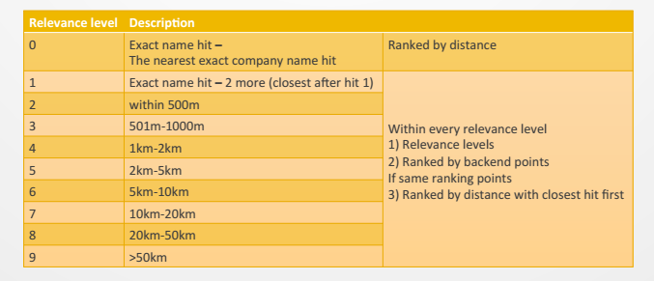

**Example on Category search:**

* Previous logic was difficult for the users to understand the results, the results are often not close to the user and by that very irrelevant, due to that, the competitions in the result list is very much limited.
* Many potential customers will have to do high investments to be presented in the search results.
* New Search logic shows relevant results close to the user but also still based on bought ranking.

**Example on Keyword search:**

The result list contains always at least 25 results (if so many available throughout the whole country)

The results list get longer and when loading more results at the end of the result list : the former result list will stay stable and new results will be added at the bottom of the result list.

**Example on Name search:**

* On name only searches (like mostly chains) we most often will show companies in the distance order.
* For ex: when searching for “Burger King” – all listings have same amount of ranking points -> we present all burger kings in strict distance order.
* For users, it does not matter which Burger King they choose.

**Current Data flow in connect:**

1. Details about an account in updated in CRM. Free listings are updated with address, phone, and email details and for paid customers product details are added.
2. Every day evening we have scheduled job which generates excel files of all the accounts, it has previous accounts also and the changes which was done over the day.
3. Once excel file is generated its copied to the Partner System using SFTP
4. The files copied to Partner System is used to generate Advert XML, these XML is the input for the production site
5. The xml file is generated using Java package eisextractor and the extractor will send activeMQ message about the XML generated to 3E systems. The 3E system in turn picks this XML for further processing.
6. 3E stands for Partner Extract Engine and is a high-performance cache for data deliveries to various systems
7. Data deliveries from backend systems(in our case advert XML) to Index
8. Technologies used are Uses JAVA,ActiveMQ,MongoDB . This is handled by Partner Team and we don’t have any control on 3E system.
9. 3E Intended as a tool where data is

* transformed (for example from XML to Advert XML),
* added together (for example Advert XML added with PSM data)
* cached for fast full file deliveries (for example to Index, which requires a new full each day, and where source systems like ECO do not provide any full files)

1. Once 3E processing done information about a customer listing is present in PS-WEB. For paid clients the product details(keywords, category/profile ad,deeplinks,offer ad,pdf,cover photo, openings hours) are added in PS WEB. Once added in PS-WEB info will be updated in advert XML file.
2. Products like logo,web address, social media links, images are taken directly from Advert XML data. Images are copied to predefined path in Partner system.
3. Categories are stored in PS-ADMIN which is updated through a scheduled job.
4. Geoareas are stored in Partner Database and is used while Advert XML are generated

**Integration Layer**

eIS have plans to become a platform aggregator by adding business category related services attached it to respective business listings, for ex: if a user searches for Hotel, we list the hotels according to the search logic and also list provision for booking Hotel rooms. To enable this, we have collaborated with Booking.com, Zomato.com, and Roundmenu.com for their respective services as listed below;

* Booking.com Affiliates partners program for real time integration with their platform, API & Technical details will be shared later.
* Zomato.com – Strategic partner program for taking the data based on manual API call, we store the data, make necessary changes and upload it to our database. With Zomato, we are also publishing the restaurant ratings in the search results & profile page. For more info, Pls refer to listings powered by zomato in Connect.ae
* Roundmenu.com – For restaurant table booking services only. API & Technical details will be shared later.

In addition to the above, we are also talking to various other service provider to have their related online services integrated to business listings to offer better user experience. Moreover we will be the first aggregated local search engine platform in the region by having such services integrated.

**Map Data**

Note that we do not have plans to work with Google in setting LAT & LON values for each business listings; rather we would have our own map platform used for this development.

Currently we have long term agreement with Map data provider to get the Map layers data and the team can customized it based on our requirements, ideally this part would be outsourced or it can be in-house team provided we have skill sets to execute it.

Configure Paid Listing Details in PS-WEB

Paid Listing Info Goes to PS-WEB

XML taken by Partner 3E System

EISExtrator Generates XML From Excel

Excel Copied To Partner System

Customer Data Stored as Excel in Staging Server

Scheduled Jobs

CRM ACCOUNTS & SUBSCRIPTIONS

CRM ACCOUNTS

Paid Listing

Free Listing

CUSTOMER LISTING

**Dataflow diagram:**

Information Available on Connect.ae

**Architecture Overview**

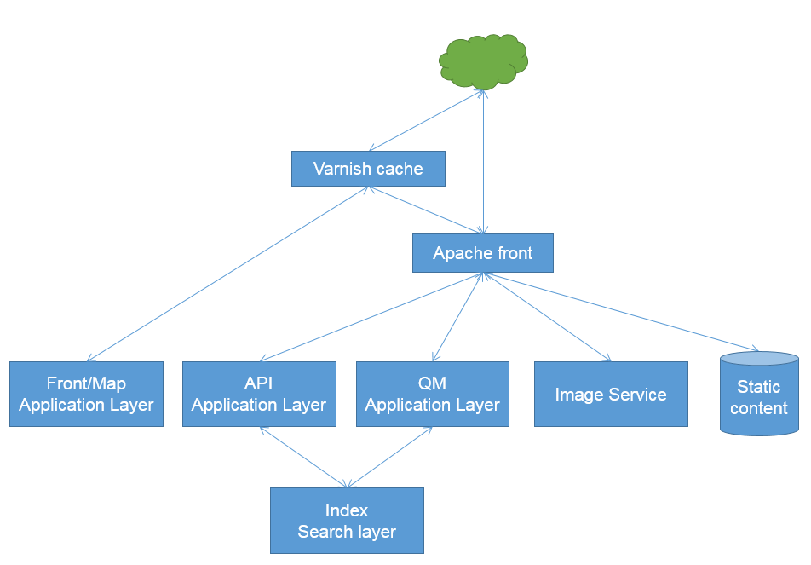

**Front Layer**

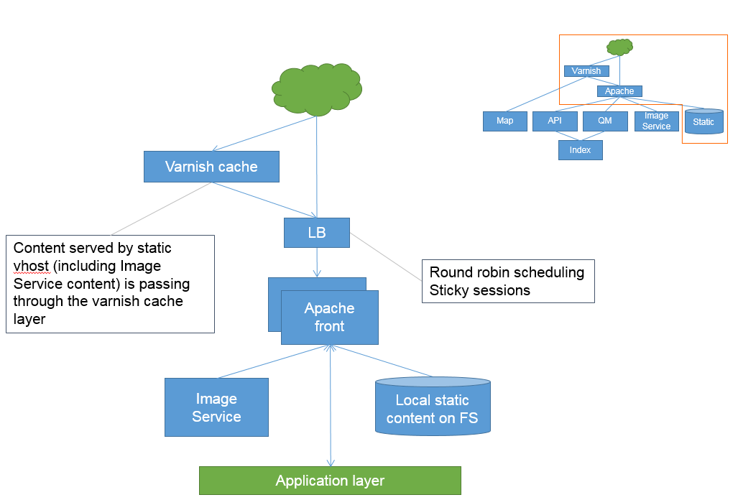

**Application Layer**

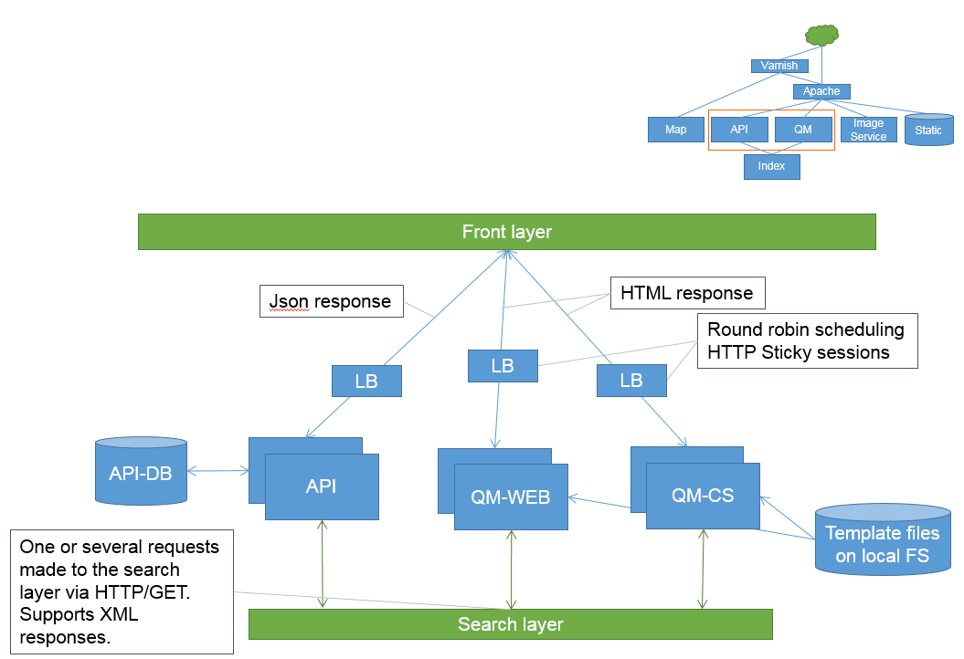

**Search Layer – Company Index**

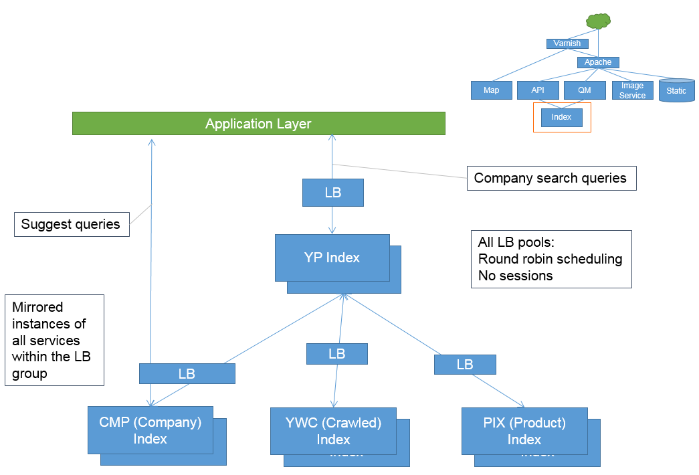

**SEO recommendations**

In the new development eIS management would like to make sure the below topics are taken care at the conceptual & planning stage itself for the new platform development.

* Hamburger Navigation in the home page, this is a mandatory requirement to be considered for the design & development stage.
* Breadcrumb trails - The breadcrumb trails are currently not optimised for keywords. The anchor text is not relevant to destination page. The Developers to amend trails to include keywords that describe landing page or alternatively add link alt text.
* Adding no follow tags in Hyperlinks/External partner services links
* Schema tag for the internal search engine - in order to output a search engine on the results pages of google (similar to youtube) a schema for the search engines and results pages should be added to the website.
* URL’s of the website - The URLs of the website needs to be properly structured and can produce various duplicate pages of the same listing or category pages depending on the usage of + or space or forward slash. Pages should all be accessed via a simple structure as follows:

Category: http://connect.ae/category

Subcategory: http://connect.ae/category/subcategory

Local Listing: <http://connect.ae/subcategory/city/listing>

* Static content for category pages - Category pages needs to have space for static content, since most of the big traffic will be generated by them, this is essential. Suggesting a content box similar to one of our other clients souqalmal.com.
* Ability to edit category pages with specific metadata outside rules - The meta data for important pages such as Hotels in Dubai has to be editable and is outputted via rules. Ideally we need the option to edit the category pages metadata and on page items such as H1 including addition of text where needed.

**Navigation Mobile App**

Each company listings (Free/Paid) will have map location added to the system and the end user needs to be navigated using a Navigation map similar to the one already live in App stores like Connect.ae Navigation map. This tool development & maintenance has been outsourced to a 3rd party developer. The new search platform development will be given contact details of this developer for integrating the search app with navigation app, as the map coordinates parameters has to be passed to different app and the experience to user has to be seamless to get Turn by Turn navigation executed in Navigation app.

eIS management also has plans to commercialize the Navigation app by creating sellable products in the app, more options can be discussed at the later stage. For now, the scope has to be envisioned for integrating the search app with navigation app.

**Adobe Site Catalyst/Analytics tool**

eIS management wants to implement in-depth analytics tool to measure & take exposure report for the clients in getting the detailed analytics of the product performance. The tool must be able to handle the below reports;

* Company search keyword – all & specific keywords
* Customer ID – company wise
* Link click report
* Map interaction report
* Site Unique visitors/visits, pageviews, sections etc.
* Most/Least viewed listings
* Most/Least leads generating listings
* Most/Least viewed multimedia (Videos/Pictures/Sound Clips)

All the above mentioned reports will be available with the following filtering criteria / information.

* Date/Time of user view/visit
* Location of users (i.e. Country, City, Community, Sub Community)
* Segments (i.e. section, category, sub category etc.)

**Admin Module/Interfaces requirements**

* Webmaster content
  + Static content on front page and subpages.
* Search Index
  + Administration of additional company data, searchability and product data feeds.
* Product Identifier
  + Verification of automatically set rules of product identification process.
  + Setup of manual product identification rules.
* API
  + API administrator.
* Booking
  + Verification of automatically matched partner entries.
  + Manually setup external customer relations.
* Advanced
  + Handling of synonyms
  + Handling of Category Keywords

**Ad management server**

All the display ads & search text ads to be controlled & monitored by a third party Ad management server. This Ad management module will have the following standard features;

**Ad trafficking and delivery**

Control when, where, and to whom, your ads appear. Use flexible delivery controls to deliver ads how you and your advertisers want to see them.

**Frequency capping**

Set multiple levels of frequency capping, which limit the number of ads the same visitor sees over a minute, hour, day, week, month, or lifetime.

**Various ad pricing models**  
Choose from cost-per-thousand-impressions (CPM), cost-per-click (CPC), and cost-per-day (CPD).

**Built-in targeting**

Target ads based on a user's geography, bandwidth, browser, browser language, operating system, and domain. Set your ads to run only during specific hours or days.

**Customizable targeting criteria**

Target ad impressions by passing your own custom key-value pairs.

**Creative preview**

Preview any type of creative exactly as it will appear on your website, mobile site or application before it's live.

**Reporting**

Fast, flexible and robust reporting allows you to optimize campaign delivery and uncover new opportunities.

**Timeline:**

* Proposals are due no later than 4:00pm, Monday, June 5, 2017
* Negotiations will begin immediately with company and should conclude no later than June 29th.
* Phase I of the project must be completed and delivered by Dec 20th, 2017.
* Engagement work complete and web site live – deliverable date to be on May 3rd 2018.

**Budget:**

Please provide several cost proposals to accomplish the scope outlined below. The budget must encompass all design, production necessary for development and maintenance of the web site.

* Phase I: Site design & definition
* Phase II: Site Development, Testing and Deployment

**Site Specifications:**

Etisalat Information Services encourages creativity in the proposals submitted; however there are certain requirements for the web site project. Your proposal must account for all of these requirements.

* Site must be compatible with IE 9.0 +, Chrome, Safari, Firefox recent versions as of Apr 2017.
* Web site must be responsive so that it can fit to different mobile browser screens.
* Website design must be SEO friendly.
* Site must be built in accordance to the Web Content Accessibility Guidelines 1.0, provided by the W3C and should also be easily accessible to the novice as well as the experienced user.
* Fast Loading Pages – The web site must be designed with a balance of text and graphics such that each page loads in 5 seconds or less on the average computer.

**Qualifications:**

* List the five web sites your firm has produced that best reflect your work and relevancy to this project. Briefly list the role your firm played in each project. The URL should be submitted. Only sites that are live will qualify during evaluation.
* Provide current reference information for three former or current clients.
* Briefly describe your firm’s organizational capacity to produce our web site (e.g. staff, equipment, software, physical space, office location, etc.).
* How many full-time staff does your firm employ? Please include a copy of your firm’s organizational chart.
* Provide a company profile, length of time in business and core competencies.
* What type of team will be assigned to this project? What will each person’s role be? Please include a brief background summary for each key staff member assigned to this project.
* Briefly describe your firm’s project management process.
* Please discuss your testing and support plan.
* Time frame for completion. The time frame for completion of the project will be evaluated. In addition, time frames will be part of the contractual agreement; therefore, a realistic time frame for completion is requested.